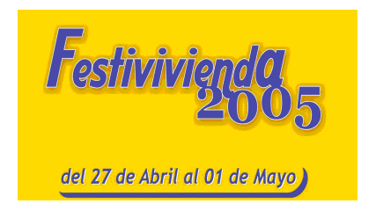
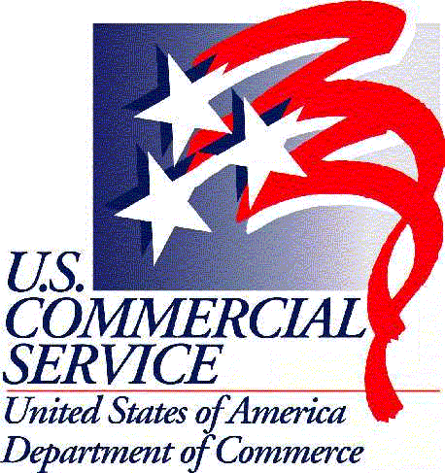

TEST A NEW MARKET !!!

3rd FESTI VIVIENDA 2005
Building & Housing Catalog Show
Lima, PERU
June 1 – 5, 2005

Contact: Manuel.Gomez-Garcia@mail.doc.gov

Why Peru?
Peru is the third largest country in the region after Brazil and Argentina, and it is three times the size of California. Peru is the fourth most populated country in South America with more than 27 million inhabitants.

There has been a seven percent increase in demand for building products in the Peruvian market during the last three years. Peruvian construction, building and housing sectors are being boosted by two Government-sponsored housing programs (i.e., Mi Vivienda and Techo Propio), increasing the opportunities for new-to-market products and technologies.

Why exhibit at Festi Vivienda 2005?
Lately, we have been working on many requests for machinery, equipment and supplies for the building & housing-related activities. With over one quarter of the local import market share, U.S. products are well positioned to take advantage of the new opportunities Peru has to offer.

3rd FESTI VIVIENDA 2005 is one of the most important building, housing, raw materials, finished products and hardware-related international tradeshow in Peru. More than 100,000 businessmen including buyers, distributors, and joint venture partners from Peru and neighbor countries
attended 2nd Festi Vivienda 2004.

The U.S. Commercial Serviceof the American Embassy in Lima, Peru
will have a booth representing U.S. firms through a catalog exhibition.

CATALOG REPRESENTATION Fee: US$ 150

A catalog exhibition is a low-cost method of promoting your product in Peru. Our Trade Specialists will promote your products, keeping in mind your company’s objectives, selling points and ideal business partners while gathering and qualifying sales leads, and assisting in follow-ups.

Festi Vivienda will take place at the Mega Plaza Norte Convention Center, April 27 – May 1, 2005. If you are interested please fill out the Registration Form and the Marketing Data Form and fax it to 011-51-1-434-3041. For more information, you may visit our website: www.BuyUSA.com.pe.

Registration is open until May 11, 2005.

You may send your company’s product literature (catalogs, brochures, flyers, DVDs, videos -VHS NTSC-) by the U.S. Postal Service “Priority Mail” until May 13, 2005 to:

Margaret Hanson-Muse
AMEMB - FCS
Unit 3780
APO AA 34031 Ref: Festi Vivienda 2005

Please do not use courier services (FedEx, UPS, DHL, etc.)

